K.H.U. Faculty of Engineering and Natural Sciences

IT 400 BACHELORS PROJECT
PROPOSAL

INTERRELATION OF SYSTEMS DEVELOPMENT APPROACH WITH PROJECT MANAGEMENT

Project Advisor: Ebru Dilan & Mehmet Nafiz Aydın

Project Team:

Pelin Pelindağ- Information Technologies
Elif Tarhan - Information Technologies

Submission Date: 11.12.2014
ABSTRACT:

The Agile Methodology provides alternative project management process instead of traditional techniques. This Methodology is used in software development to help businesses requirements. Customer needs are solved by rapid, continuous delivery of useful software. Customers, developers and testers constantly interact with each other.
The most popular agile methodologies are below:
- DSDM
- Scrum
- XP (Extreme Programming)
In this project, we are going to analyze one of the Agile Methodologies that is Scrum.
Scrum’s aim is to manage tasks within a team-based development environment. Scrum is the most popular and widely adopted agile method, because it is very simple to implement to the projects. And also, Scrum provides to make changes easily in chaotic situations.
Scrum has three roles: Product Owner, ScrumMaster, and team member. All of these project members contribute to project development. [4,5,6]

AIM:

This project’s aim is, to analyze Scrum Methodology, it's usage environments and evaluate the Scrum's applicability. We are going to work with a company which implement Scrum Methodology. We are going to investigate that how the company uses Scrum Methodology and the advantages and disadvantages of Scrum. Also, we are going to determine who can attend in scrum project role and Scrum Method how can affect the completion time of project. (YITMEN, 2000)
METHODOLOGY:

- Literature review: We need to look at existing reseach that is significant to our project.And we need to evaluate the results so we can have a chance to see different works and relationships with our subject. To review a literature ; we need to know what to do , which subject we need to look at .(Swales J. ,1990)
- Qualitative approach: While we are doing qualitative research we will look in –depth at non numerical data (Mack, N., Woodsong, C., MacQueen, K. M., Guest, G., & Namey, E. 2005)

- Case study : While doing case study we have a chance to study one aspect of a real-world problem in detail and we have a chance to see many different viewpoints.
- Data collection:During the case study research we will collect the data first. And try to make sense for our project. For collecting these data we will do interview (with different roles) and review project documents in organization.
- Data analysis: To analyze the interview result, keyword analysis will be used.
- Findings will be given in a summary table

WORK PACKAGE DESCRIPTION

GRADUATION PROJECT
PM
Application for submission
Writing proposal
Develop project schedule
CONCEPTION
Determine initial title
Define research problem
Determine methodology
LITERATURE REVIEW
Searching for relevant studies
Reviewing relevant articles
CASE STUDY
Making Interviews
Analysing Interview Results
Review Project Documents
RESULT
Table of Contents
Case analysis
Findings
Conclusions
Introduction
Finalizing research title
Abstract/Keywords
Final Report Submission

WORK PACKAGE DESCRIPTION

Number and name of the package:1st packet Project Initiation and Planning

Start date:14 November 2014

Finish date: 18 November 2014

Short description: In this packet we will do , Application for submission , Writing Proposal & Develop project schedule

Methodology: We will do literature review, and searching academic resources.

Outputs: Proposal & project schedule

Relations to other packages: When finishing first packet other packet will start.

Working team members (with contributions as percentages of the work packet):
Pelin Pelindağ 50%
Elif Tarhan 50%
Work to be done by any body outside the team: N/A

WORK PACKAGE DESCRIPTION

Number and name of the package:2nd packet Conception

Start date:14 November 2014

Finish date: 21 November 2014

Short description: In this packet we will do , determine initial title, define research problem,determine methodology
Methodology: In this packet our aim is define all project concept and define research problem

Outputs: Title , Research Problem & Methodology

Relations to other packages:It will start with the first packet .

Working team members (with contributions as percentages of the work packet):
Pelin Pelindağ 50%
Elif Tarhan 50%
Work to be done by any body outside the team: N/A

WORK PACKAGE DESCRIPTION

Number and name of the package:3rd packet Literature Review

Start date:17 November 2014

Finish date: 6 January 2015

Short description: In this packet we will do , Searching for relevant studies review relevant articles

Methodology: : We will do literature review, and searching academic resources.

Outputs: Knowledge about our research subject

Relations to other packages: it will start after the second packet

Working team members (with contributions as percentages of the work packet):
Pelin Pelindağ 50%
Elif Tarhan 50%
Work to be done by any body outside the team: N/A

WORK PACKAGE DESCRIPTION

Number and name of the package:4th packet Case Study

Start date:14 January 2015

Finish date: 13 February 2015

Short description: In this packet we will do , Making interview ,Analysing Interviews result,Review Project documents
Methodology: While we are doing case study, we will interview with the people in an organization . We collect information about organization and we analyze these information.

Outputs: Understanding of organization’s project

Relations to other packages: It will start after the 3th packet

Working team members (with contributions as percentages of the work packet):
Pelin Pelindağ 50%
Elif Tarhan 50%
Work to be done by any body outside the team: N/A

WORK PACKAGE DESCRIPTION

Number and name of the package:5th packet Result

Start date:16 February 2015

Finish date: 30 April 2015

Short description: In this packet we will do , Preparing table of contents, Document Case studies, Findings, Conclusion ,Introduction , Finalizing Research Title, Abstract/Keywords .

Methodology: For the final report , after the previous packet which is 4th packet we create findings with summary table for the final report

Outputs: Final Report

Relations to other packages: When finishing 4th packet it will start.

Working team members (with contributions as percentages of the work packet):
Pelin Pelindağ 50%
Elif Tarhan 50%
Work to be done by any body outside the team: N/A

CONTRIBUTIONS OF THE TEAM MEMBERS:

Name, Surname | Work Packages |  |  |  |  |  |  |  |  | Total
Name, Surname | I |  | II |  | III |  | IV |  | V
Name, Surname | h | % | h | % | h | % | h | % | h % | h | %
Pelin Pelindağ |  | 50 |  | 50 |  | 50 |  | 50 | 50 |  | 50
Elif Tarhan |  | 50 |  | 50 |  | 50 |  | 50 | 50 |  | 50
Total |  | 100 |  | 100 |  | 100 |  | 100 | 100 |  | 100

PROJECT CALENDAR

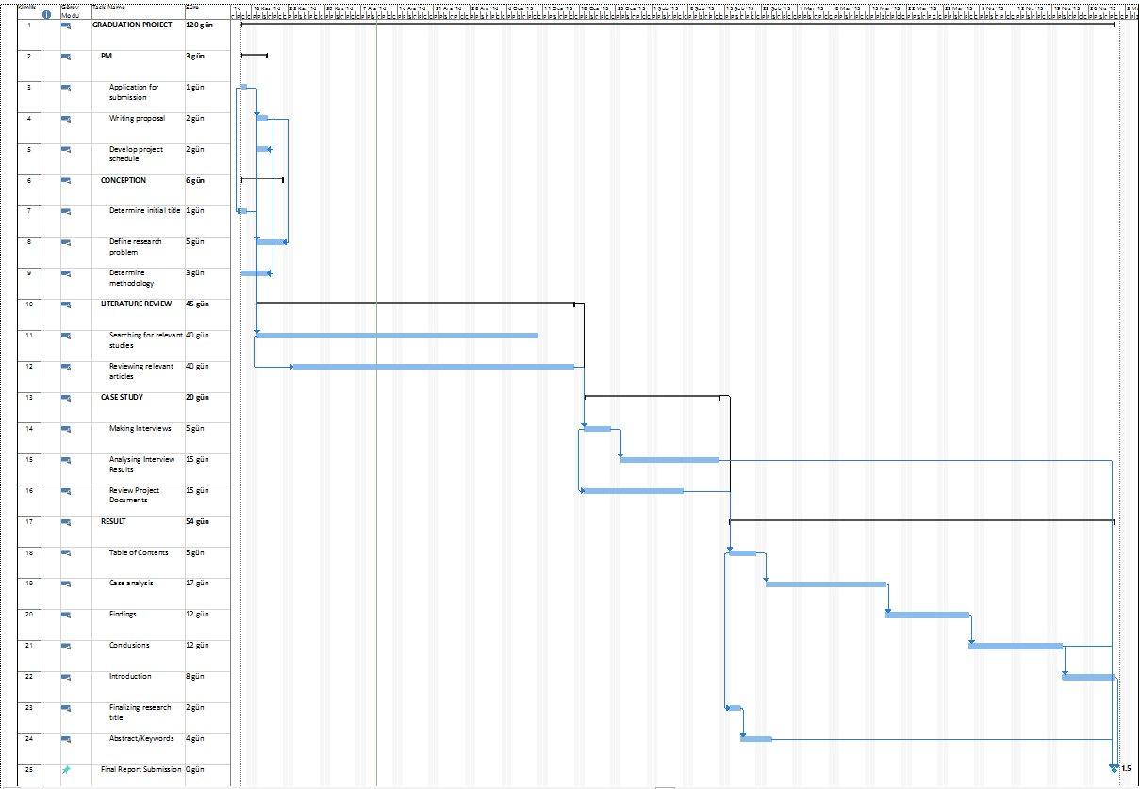
REFERENCES:

[1]. Mehmet YITMEN, A.N., Bir Dönüşüm Hikayesi - Agile Proje Yönetimi, Seçkin Yayıncılık, Ankara, 2000.
[2] Mack, N., Woodsong, C., MacQueen, K. M., Guest, G., & Namey, E. (2005). Qualitative research methods: a data collectors field guide.
[3] Swales, J. (1990). Genre analysis: English in academic and research settings. Cambridge University Press.
[4] Agile Methodology. [online] http://agilemethodology.org/ (Accessed 10 December
2014).

[5] Scrum Methodology. [online ]http://scrummethodology.com/ (Accessed 10 December 2014)
[6]Scrum alliance [online] https://www.scrumalliance.org/why-scrum (Accessed 10 December 2014)

